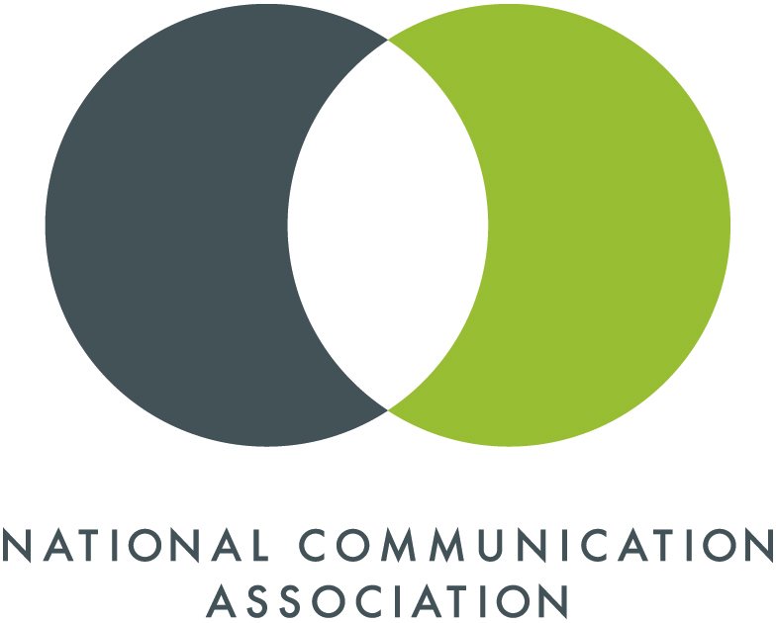
National Communication Association
Application for Doctoral Honors Seminar
July 23-26, 2018
Department of Communication Studies, Vanderbilt University

Please include this as the cover sheet to your application.
Name: __________________________________________________________ Email: ________________________________
Advisor’s Name: _________________________________________________________________________________________
Title of Project: ___________________________________________________________________________________________
Department and University: _____________________________________________________________________________
Please indicate the following:
1. What level of Ph.D. work will you begin in the Fall of 2018 (check all that apply)?
second year third year preparing for comprehensive exams pre-prospectus
approved prospectus dissertating
2. The research paradigm that best describes the one used in your project:
critical/cultural/rhetorical interpretive post-positivist
3. In what sub-field would you prefer to be placed?
mass media rhetoric social science
4. Ordinarily students submit a paper that is preparatory for the dissertation or they submit an edited version of the prospectus for their dissertation. If you are not at that stage in your doctoral work, please send a paper that is central to your work. In addition, we are interested in learning if you have submitted this project for presentation or publication. If you have done so, please indicate where it has been submitted and the outcome of that submission.
_____________________________________________________________________________________________________________________________________________________________________________________________________________________________________________________________________________________________________________________________________________

